**CEG4913 Weekly Progress Report**

Week #: 4

SCRUM/Sprint No. 12

Group Number: 3

Date: October 2nd, 2025

One line summary of progress:

Development of database completed and dockerized Jetson development for remote access.

# Work Completed

## Hardware:

* Hardware has arrived
* Enabled CUDA on the jetson

## Software:

* Database fully setup
* Dockerized Jetson dev environment
* Integrated APIs
* Designed APIs for UI screen
* Developed the three pages of the UI screen

## Team Member Contributions:

Aaditya Shah:

* Enabled CUDA on jetson
* Debugged use of CPU instead of GPU for python models

Abdullah Ramadan:

* Fixed CI pipeline on github actions (file syntax and pr naming convention)
* Added documentation to commit using pull requests
* Got HW specifications

Keith Tran:

* Started to work on Twilio integration
* Started implementation for sensor data APIs

Kevin Dang:

* Integrated CRUD APIs for users
* Researched login authentication

Hajer Fguir:

* Developed the 3 first pages (Login page, Driver Selection Page, Status processing page) of the UI screen using React - Light/dark Mode
* Prepared the environment for backend integration
* Started the Midterm Presentation Slide Deck

Saurav Guduru:

* Debugged issues setting up database secret keys
* Completed research for main thread usage

## Issues and Resolutions:

Issue: None

Status: N/A

Resolution: N/A

# Plans for next week:

## Hardware Goals:

* Prepare demo for midterm
* Test the new hardware that arrived

## Software Goals:

* Update slide deck for presentation
* Continue with API integration and testing
* Continue with the new UI Screen dev
* Integrate backend APIs into the UI screen pages
* Figure out jetson GPU usage for models

## Management Board Screenshots:

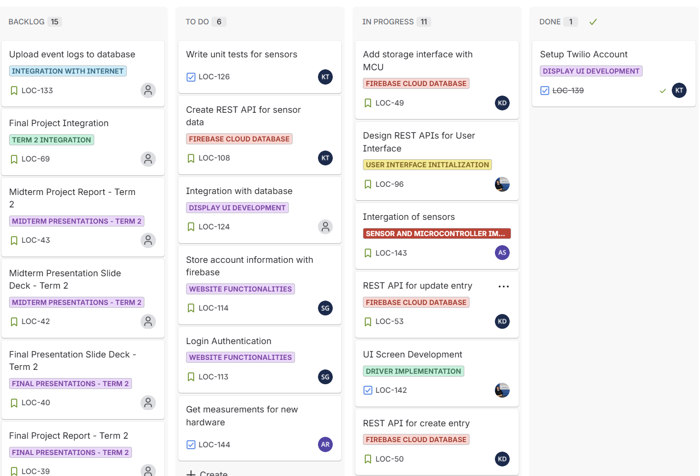

Figure 1 - General Management Board

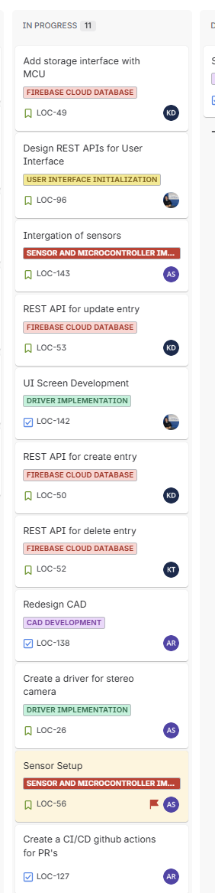

Figure 2 - This Week’s Sprint

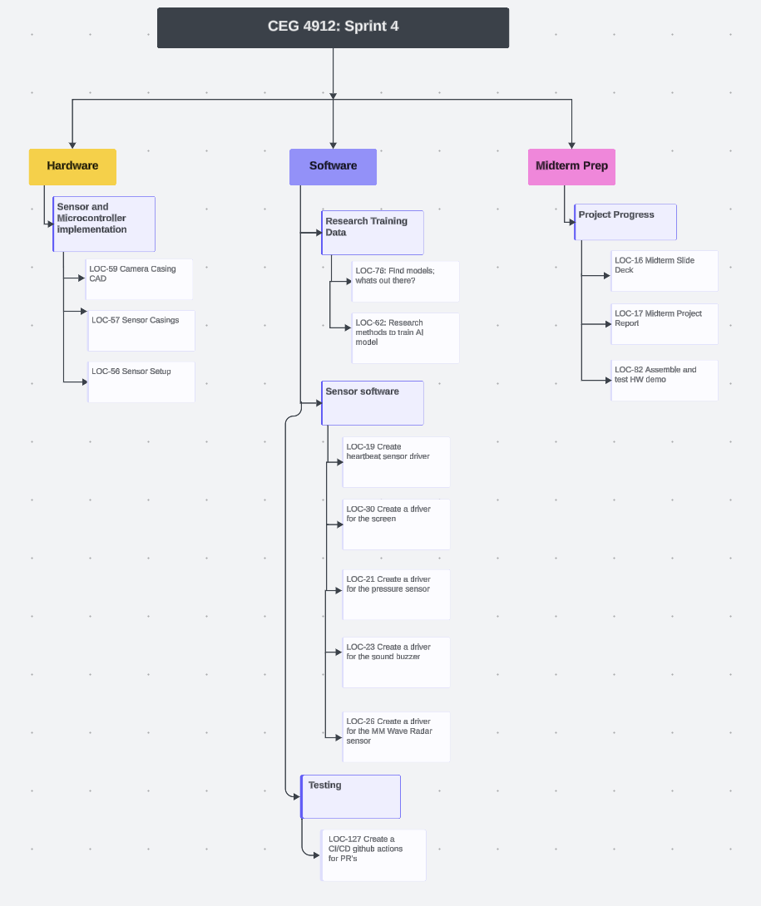

Figure 3 - WBS

## Additional Notes: